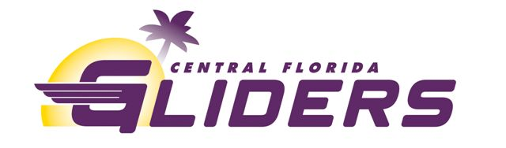
2022 Cross Country Season Summary
The cross-country season started in September with our registration meeting and first practice. One of the first races of the season was the FLYRA qualifier at Holloway Park where several Gliders qualified for the Florida Middle School State Championships.
In October, the Gliders hosted its annual cross country meet at Forest City elementary instead of Sanlando Park where we have had the race for years. This year it was an invitational sanctioned by USATF rather than AAU and was a qualifier for the Middle School Championships. The Gliders had a fun practice on New Smyrna Beach and another at M.L. King Park in Winter Park. Several Gliders performed well in the FLYRA Middle School State Championships while several high school Gliders competed in the district and regional championships. One Glider made it to the cross-country state championships in their Freshman year!
The first week of December, five Gliders competed in the AAU National Cross-Country Championships which this year was back in Knoxville at Victor Ashe Park where two Gliders medaled by finishing in the top 25 of their respective age groups.
While in Knoxville, the team visited for the second time, the Cirrus Aircraft company where the athletes toured the facility and learned a lot about becoming a pilot and flying an airplane. We ate lunch again at Calhoun’s on the Tennessee River. On Saturday after the races, we visited Pigeon Forge and took in the fabulous Christmas decorations.
The club shopped for presents and necessities to support three local families during the Christmas holiday.
Sincere thanks to the Track Shack Foundation, Help Kids Play Sports, Dule Energy, Publix, Amazon as well as several other individual alumni donors for supporting our cross-country team and charitable efforts this season. www.cfgliders.com

